**Week 3 Quiz - Incorrect Answer Explanations**

**Question 1:**

The marks on this question has baffled me as I thought it was relatively straight forward.

Firstly, I calculated the mean using my notebook (I got 17.9), I calculated it with my scientific calculator (I got 17.9) and I also calculated it with an online mean tool (they also got 17.9). However, 17.9 seems to be the wrong answer - I don’t understand why.

Secondly, I got the mode wrong. This really left me perplexed. I thought this was one of those ones which didn’t require any sort of working out, it is quite obvious to see from the table that the age 18 is the most frequent (count of 15). However, I also got this wrong. (Note: I don’t think it is wrong because I didn’t write ‘18.0’, as my answer for the median was ‘18’ and that was marked correct).

**Question 3 (the first part):**

I answered, ‘equal to 13’. This was marked incorrect. Using the week 3 solutions, I used the function ‘calc_median’ (same as my function from my week 3 python book) to calculate the median of a test data set:

**mdata1 = [1,4,9,10,13,13,15,16,18,19,15]**

Firstly, the only way to get a median sample value of 13 is to have two 13’s as the middle elements. See below for the median when the 5th and 6th elements are changed.

When 6th is 13 only:

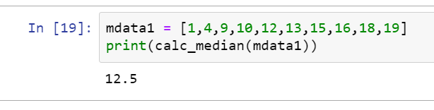

When 5th is 13 only:

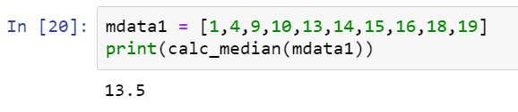

When both 5th and 6th 13:

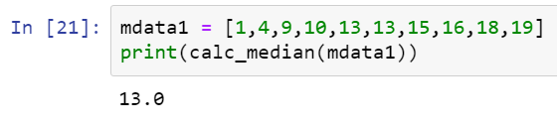

Now, the first part of the question says the value 15 is added. Therefore, when it is added, it has no effect on the median and 13 stays as the median. See below, when 15 is added and sorted in the data set.

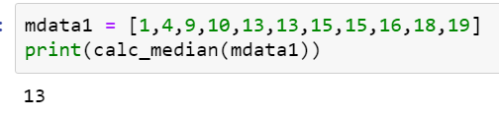

Therefore, I believe my answer to this question is correct. Please can an explanation be provided as to why it is not.

**Question 4 (IQR bit):**

When I calculated the IQR using manual methods and online tools, I also got the vale 1.22 (which is correct). However, using my function for percentile calculations (see part c of my uploaded notebook) and then getting the difference of the 75th and 25th percentiles I got the value 1.250 (see below).

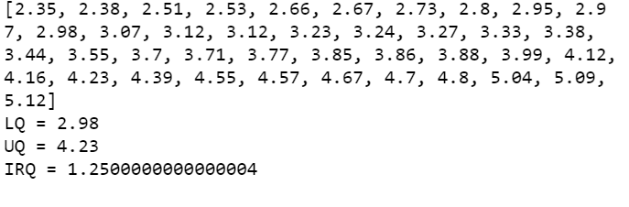

I believe this result has come about because of the percentiles being calculated differently. Please can you check over my functions and results in the notebook and award partial marks if possible.